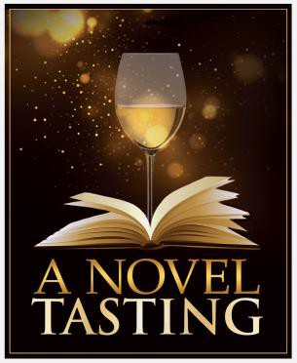Third Annual

A NOVEL TASTING

An Evening Benefiting the Birmingham Public Library

About the Event
On Thursday, April 11, 2024, the Birmingham Public Library (BPL) will host its 3rd annual A Novel Tasting fundraiser. The evening will feature a tasting of fine wines, locally crafted beers, and distilled spirits. Guests will enjoy live music, complimentary drinks, catered food, a silent auction, and more. A VIP reception will be held before the event.

About BPL
Your sponsorship of A Novel Tasting will help the Birmingham Public Library fulfill its mission of providing the highest-quality experience of lifelong learning, cultural enrichment, and enjoyment to the community. Proceeds from the event will fund programs at all BPL locations.

About the Friends Foundation
The Friends Foundation of the Birmingham Public Library is an independent 501(c)(3) tax-qualified, non-

Presenting Sponsor ($5,000)
- 10 tickets to VIP Reception
- Recognition at the event as official Signature Sponsor
- Promotion as Signature Sponsor in all media coverage
- Personalized gift and gift basket
- Customized bottomless-pour wine glass
- Admission to A Novel Tasting

Sponsorship Agreement
Contact Name Company Name _ Street Address City, State, Zip Code Phone Email

Payment Method

profit organization. It is dedicated to supporting the Purchase online by clicking here
programs, services, and partnerships of BPL through

advocacy, outreach, and fundraising. Working closely with BPL staff, the Friends Foundation helps the Birmingham Public Library be the best library it can be.

Sponsorship Opportunities
Signature Sponsor ($10,000)
- 15 tickets to VIP reception
- Recognition at the event as official Signature Sponsor
- Promotion as Signature Sponsor in all media coverage
- Personalized gift and gift basket
- Customized bottomless-pour wine glass
- Admission to A Novel Tasting
Check
Please make your check payable to the Friends Foundation of the Birmingham Public Library. This letter serves as your official tax receipt. Please send your company logo to Margaret Splane no later than Friday, March 15, 2024.

Additional Information
Please contact Margaret Splane at 205-226-3728 or margaret.splane@cobpl.org.

